Permission group for someone having visibility to EMEA and APAC Compensation

- Steps :
  - Create Permission group for the Team mate :Administrator: Compensation (APAC/EMEA)
  - Create a Target Population group for the Team mate :Target Population: APAC/EMEA
    - Define a Target Population -This means any admin is this user group has visibility and edit access to this Target Population Permission group
  - Run a report to check how many AMEA and APAC Team members. Make sure the number of Active Group members coming up matches the numbers in the report
  - Create Permission Role :Compensation Administrator (APAC/EMEA)
  - Assign this role to the new Comp Admin group Administrator: Compensation (APAC/EMEA)
  - For Comp Admins : Compensation Home > Action for all Plans > Group Assignments > Manually assign the Comp Admin group name

- Create Permission group for the Teammates that will give visibility to EMEA and APAC only
- Copy the Comp Admin group we currently have and create a new one -Administrator: Compensation (APAC/EMEA)
- View the group - Delete al the Team members tied to the overall Comp group - Add the team member to the new group created
- 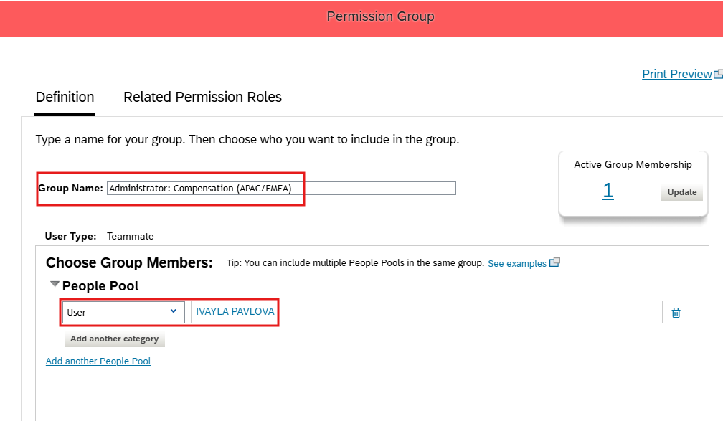
- Create a Target Population for the Team mates who will have visibility to EMEA and APAC
- Create a target Population group - Target Population: APAC/EMEA
- Run a report to check how many AMEA and APAC Team members we have to make sure number of Active members coming up matches the numbers in the report
- 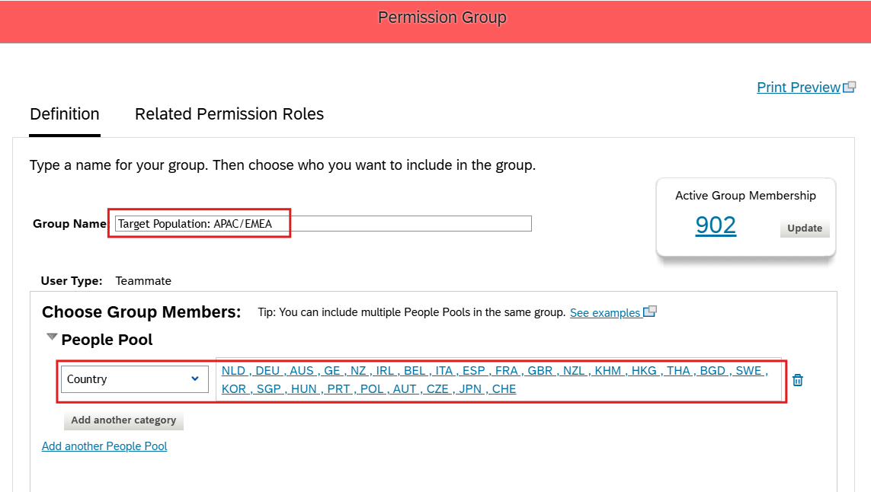
- Go to Permission role. Copy over the Comp Admin Role and make this into Compensation Administrator (APAC/EMEA)
- 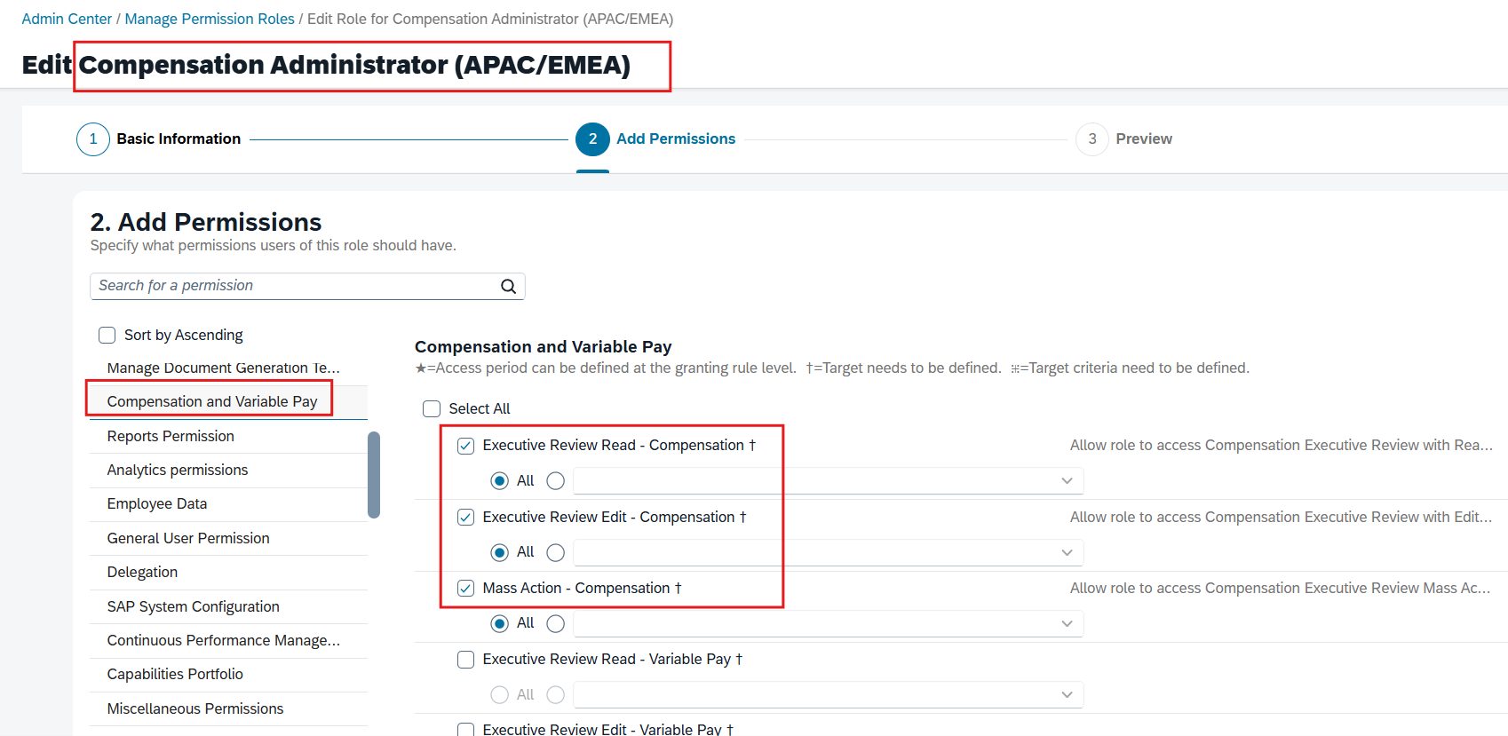
- Assign this role to the new Comp Admin group that we created : Administrator: Compensation (APAC/EMEA)
- Define a Target Population - By the permission group that we just created : Target Population: APAC/EMEA -> This means any admin is this user group has visibility and edit access to this Target Population Permission group
- For Comp Admins : Compensation Home > Action for all Plans > Group Assignments > Manually assign the Comp Admin group name
  - This is a special permission that allows the admins special permissions to the Comp form. Without this permission the Team mate in these newly created permission groups will not have access to the Comp forms
- 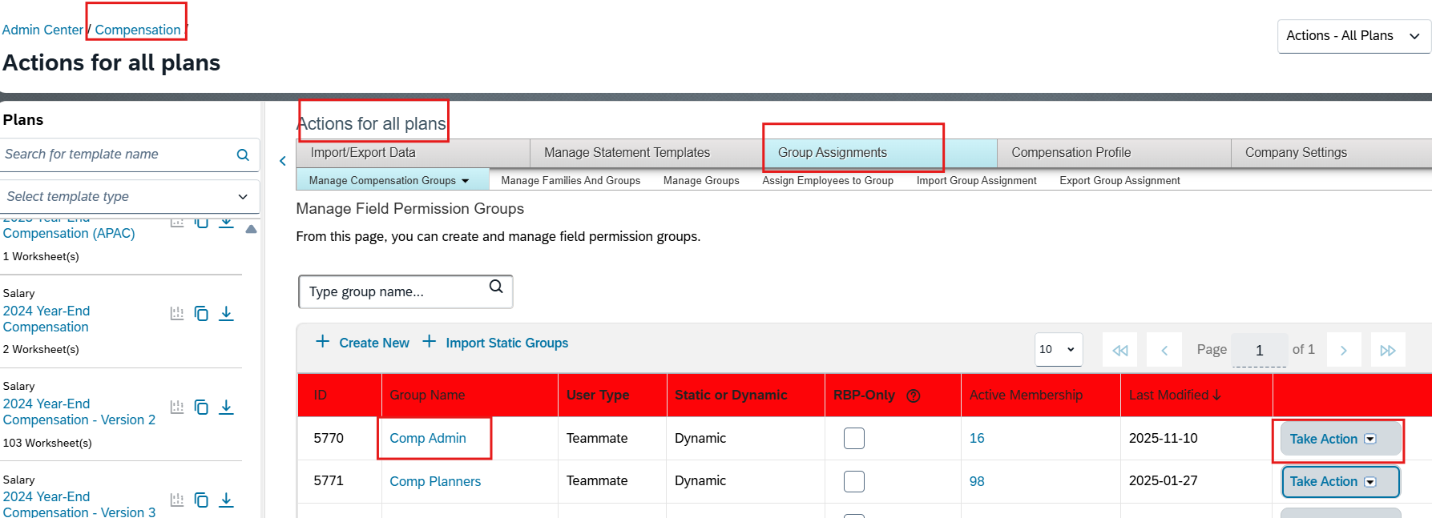
- 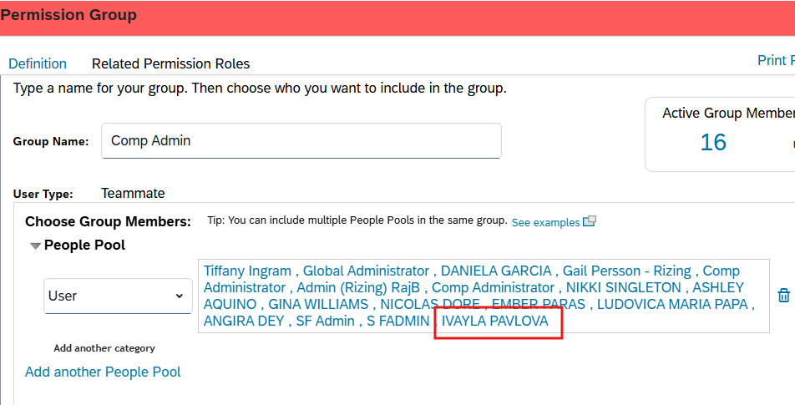
- Sign in as the Team member Ivayla Pavlova - validate she will have Comp, Comp forms for EMEA and APAC, check to see if she can run reports

